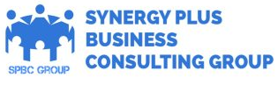

What We Do:
- Recruitment & Staffing Services
- HR Consulting
- Training & Development
- Payroll Management
- Performance management
- Talent Acquisition
- HR Technology solutions
- Employee Relations
- Compliance & Legal services
- Background verification
- Global HR Services
- Accounting & Audit & Taxation Services

- Corporate Services
- Electrical Services & Electrical Audit
- Engineering Services
- AMC services & Repair
- Project Management
- Sales & Digital marketing
- Travel Services
- Security Services
- Housekeeping & Cleaning
- Pest control Services

